The Commission Question
How Does Commission Work, Anyway?
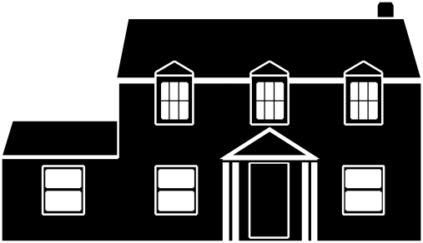

Buyer’s Agent
- Home buying advisor
- Analyzes market conditions
- Handles negotiation
- Ensures property repairs are complete
- Coordinates Inspections and Closing
- Ensures Buyer interests are promoted and protected
- Shares commission with listing agent

Buyer Commission
- Buyer usually pays no commission fee
- It costs the Buyer no money to have an agent representing them
- Buyer does not save any money for the Seller by not using an Agent, since Agents share commission
- The only exceptions are usually “For Sale By Owner” homes, and some “New Construction” that are not listed by a real estate agent, that may not have commission built in to the sale price.

Listing (Sellers’) Agent
- Markets home to potential Buyers
- Coordinates Showings
- Obtains the best sale price possible
- Negotiates with the buyer’s agent
- Coordinates Inspections and Closing
- Works with escrow for smooth closing
- Ensures Seller interests are promoted and protected
- Shares commission with the buyers’ agent – if there is one

Seller Commission
- Pays commission out of the selling price
- Percentage is set when the Listing Agreement is created
- Almost always a percentage of the selling price

Amber Wheelock
ThisForeverHome@Gmail.com
ThisForeverHome.com
208-818-4363
